Acupuncture Health History Form
Patient Information
Name |  | Date
Address
City | State | Zip
Home Phone |  | Cell Phone
Heiqht Weiqht | Sex: □ Male | □ Female Marital Status
Date of Birth | Aqe
Occupation | Employer
Have you had acupuncture before? □ No □ Yes, Name of Acupuncturist
Major Complaint
Primary reason for your visit today?
Has this condition been diagnosed by a physician, or other provider?
□ No □ Yes, Diagnoses
Are you being treated for this condition by anyone else? □ Yes □ No
If yes, what is the treatment?
Have these treatments helped? □ Yes □ Somewhat □ Not Much □ Not At All
How does this condition affect you?
How long have you had this condition?
Personal Health History
Your general health as a child was? □ Excellent □ Good □ Average □ Poor
Did you feel safe and nurtured as a child? □ Always □ Usually □ Sometimes □ Never
Check all the illnesses or conditions which you currently have or have had in the past:
- AIDS/HIV
- Alcoholism
- Allergies
- Antibiotic Use
- Asthma
- Bleed Easily
- Cancer
- Chicken Pox
- Diabetes
- Drug Abuse
- Eating Disorders
- Epilepsy
- Glaucoma
- Heart Disease
- Hepatitis
- High Blood Pressure
- High Fevers
- Hyperthyroid
- Hypothyroid
- Jaundice
- Kidney Disease
- Measles
- Meningitis
- Mental Illness
- Multiple Sclerosis
- Mumps
- Obesity
- Pneumonia
- Polio
- Other
- Rheumatic Fever
- Scarlet Fever
- Sexually Transmitted
Disease
- Stroke
- Tuberculosis
- Typhoid Fever
- Ulcers
- Vascular Disease
Are you taking Coumadin or Warfarin? □ Yes □ No
Do you have a pacemaker? □ Yes □ No Do you have seizures? □ Yes □ No
Do you currently have any infectious diseases? □ Yes □ No □ Possibly
If yes, please identify: □ HIV/AIDs □ Hepatitis B □ Hepatitis C □ Flu / Cold n Streptococcus
□ Mononucleosis □ Tuberculosis □ Other
Known or suspected allergies:
Page 1

Personal Health Inventory
Please put a check mark ( ✓ )by the symptoms that you have now.
Place a star ( * ) next to the ones you have noticed within the last three months.

Qi, Blood, Yin, Yang
- anxiety
- catches colds easily
or frequently
- chest pain traveling to shoulder
- cold feet
- cold hands
- difficult to concentrate
- dizziness
- dream disturbed sleep
- dry skin
- fatigue
- feverish in the afternoon
or flushes
- general weakness
- heat sensations in hands,
feet, chest
- insomnia
- mental confusion
- night sweats
- palpitations
- restlessness
- sores on tip of tongue
- speech problems
- sweats easily
- thirst, at night
- you feel worse after exercise
- you see floating black spots

LU
- allergies
- chills alternating with fever
- cough
- difficulty breathing
- dry mouth, throat, nose
- feeling achy
- headaches
- nasal discharge
- nose bleeds
- shortness of breath
- sinus congestion
- sneezing
- sore throat
- stiff neck/ shoulders

SP
- abdominal bloating and / or
gas after eating
- belching
- chest congestion
- constipation
- diarrhea
- eating disorders
- fatigue after eating
- gas
- general feeling of heaviness
in your body
- hemorrhoids
- loose stools
- low appetite
- mental heaviness,
sluggishness or fogginess
- nausea
- prolapsed organs
(previously diagnosed)
- swollen feet
- swollen hands
- you bruise easily

ST
- bad breath
- belching
- bleeding, swollen or
painful gums
- burning sensation after eating
- constipation
- heartburn
- large appetite
- mouth sores
(canker or cold sores)
- stomach pain
- vomiting

HT/PC
- chest pain
- edema
- high blood pressure
- insomnia
- low blood pressure
- palpitations
- stroke
- varicose veins

LR/GB
- bitter taste in mouth
- blood shot eyes
- blurred vision
- chest pain
- convulsions
- diarrhea alternating
with constipation
- difficulty swallowing
- dry eyes
- feeling of a lump in
your throat
- headache at the top of
your head
- hot flashes
- muscle spasms, twitching,
cramping
- numbness of hands and feet
- pain in rib cage
- red, sore or irritated eyes
- seizures
- skin rashes
- tight feeling in chest
- TMJ or locked jaw
- you anger easily
- you feel better after exercise

KI/BL
- frequent urination
- hair loss
- joint pain
- lack of bladder control
- loose teeth
- low back pain
- memory problems
- night blindness or low vision
- ringing in your ears
- sore, cold or weak knees
- you get up more than one
time at night to urinate
Other __________________ __________________________________________________________________________________________________________________________________________________________
Page 2

Family History
How do you feel about the following areas of your life in the past month?
Significant Other □ Great □ Good □ Fair □ Poor □ N/A Comments
Family □ Great □ Good □ Fair □ Poor □ N/A Comments
Self □ Great □ Good □ Fair □ Poor Comments
Check illnesses which have occurred in any of your blood relatives:
- Alcoholism □ Cancer □ Pleart Disease □ Mental Illness
- Allergies □ Diabetes □ High Blood Pressure □ Obesity
- Bleed Easily □ Epilepsy □ Kidney Disease □ Stroke
- Other
Women Only
Are you pregnant? □ Yes, How many months? □ No □ Trying □ Maybe
Method of birth control?
Age of First Menses Date of Last Menses Age of Menopause
Typical Length of Menses (Days You Bleed)
Typical Length of Cycle (From the 1st Day of One Cycle to 1st Day of the Next)
Number of: Pregnancies | Births Abortions | Miscarriages
Hysterectomy □ Yes □ Partial | □ Complete Date | □ No
Check all that apply to you:
□ Scanty Flow | □ Painful Periods | □ Low Libido
□ Heavy Flow | □ Breast Tenderness | □ Excessive Libido
□ Clotting | □ Breast Lumps | □ Painful Intercourse
□ Vaginal Discharge | □ Nipple Discharge | □ Infertility
□ Abnormal Pap Smear | □ Fibrocystic Breasts | □ Fibroids
□ Menopausal Symptoms | □ Bleeding Between Cycles | □ Endometriosis
□ Premenstrual Problems | □ Irregular Cycles | □ Ovarian Cysts
□ Other
Men Only
Check all that apply to you:
- Low Libido □ Seminal Emissions
- Excessive Libido □ Premature Ejaculation
- Impotence □ Painful Intercourse
- Vasectomy, Date
Other
- Prostate Problems
- Testicular Pain
- Testicular Redness
- Testicular Swelling
Page 3

Medications Please list medications, herbal supplements and vitamins you are currently taking:
How would you rate the following areas of your health in the past month.
Digestion □ Great □ Good □ Fair □ Poor Comments
Stools □ Great □ Good n Fair □ Poor Comments
How many times per day? Do they feel complete? □ Yes □ No
Stool consistency? □ Loose □ Formed □ Hard to Pass □ Other
What is the color of your stools?
Is there blood in your stools? □ Yes □ No How Often?
Urination □ Great □ Good □ Fair □ Poor Comments
How many times per day? What color is your urine?
After you've gone to sleep do you get up to urinate? □ Yes □ No How Often?
Is your urination painful? □ Yes □ No
Appetite □ Great □ Good □ Fair □ Poor Comments
Diet □ Great □ Good □ Fair Q Poor Comments
Are you vegetarian or vegan? □ Yes □ No For how long?
Food / Drink:
Foods You Crave When?
Daily Water Intake Daily Soda Intake Caffeine? □ Yes □ No
Daily Coffee Intake Caffeine? □ Yes □ No Daily Tea Intake Caffeine? □ Yes □ No
Do you drink alcohol? How Much? How Often? What kinds?
Past Use? □ Yes □ No Date Stopped
Do you use tobacco? □ Yes □ No Past Use? □ Yes □ No Date Stopped
Do you use recreational drugs? □ Yes □ No Past Use? □ Yes □ No Date Stopped
How do you feel about the following areas of your life in the past month.
Energy □ Great □ Good □ Fair □ Poor Comments
On a scale of 1 to 10? (10 is high energy)
□ Great □ Good □ Fair □ Poor Comments
Sleep
Sex Life
School
Exercise
Hours per night? _
- Great □ Good
- Great □ Good
- Great □ Good
How often?
- Fair □ Poor
- Fair □ Poor
- Fair □ Poor
Do you wake feeling rested? □ Yes □ No
Comments
Comments
Comments
What kind?
How would you rate your stress level on a scale of 1 to 10? (10 is high stress)
How well do you feel you handle your stress? □ Great □ Good □ Fair n Poor
Page 4

Drug / Supplement / Vitamin Reason For Taking For How Long Dosage Frequency

Lifestyle

Pain
Please answer the following questions if you have pain.
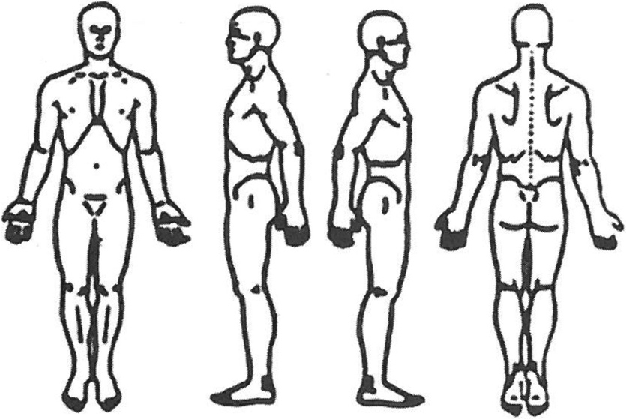
Indicate on the diagram your areas of pain
How long have you had this pain?
Describe the onset of your pain? ____________ _____________________________________________________________________________________________________________________________________________________________________________________________________________________________________________________________________________________________________________________________________________________________________________________________________________________________________________
On a scale of 1-10 (10 being worst) how
strong is your pain?
What does your pain feel like? (check all that apply)
- Dull □ Sharp □ Stabbing □ Sore □ Achy □ Cramping □ Burning □ Constant
- Comes and Goes □ Fixed n Moves About
Does the pain radiate? □ No □ Yes Where?
What helps the pain? □ Ice □ Heat □ Rest □ Movement □ Pressure □ Moisture
- Massage □ Nothing □ Other
What aggravates the pain? □ Ice □ Heat □ Rest □ Movement □ Pressure □ Moisture
- Massage □ Nothing □ Other
Does anything relieve this pain? (i.e.; medications, over the counter drugs, liniments)

_________________________________________________________________________________________
Other treatments you have had for this pain?______________________________________________________ ____________________________________________________________________________________________________________________________________________________________________________________
Anything you wish to add? ____________________________________________________________________ ______________________________________________________________________________________________________________________________________________________________________________________________________________________________________________________________________________
The above information is true to the best of my knowledge.
X Patient's Signature Date
Page 5

